**Analytical SQL Business Queries**

-----> Query 1<------

WITH cte AS (SELECT country, FORMAT(country_revenue, '#,###.##') AS revenue,

RANK() OVER (ORDER BY country_revenue DESC) AS country_rnk

FROM ( SELECT DISTINCT country,

ROUND(SUM(quantity * price) OVER (PARTITION BY country)) AS country_revenue

FROM table_retail ) x)

SELECT * FROM cte

WHERE country_rnk <= 10;

This query retrieves the top 10 countries with the highest total revenue based on the sales data stored in the online retail dataset, This query can help business stakeholders identify which countries are the most profitable in terms of retail sales and can inform strategic decisions around targeting those markets for growth.

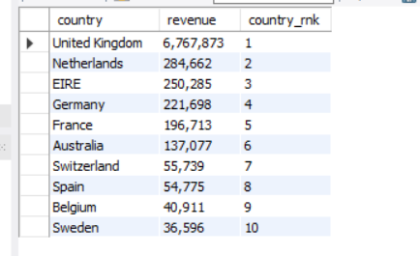

-----> Query 2 <------

select StockCode , FORMAT(product_sales, '#,###.##') product_sales ,rank() over(order by product_sales desc) as product_rnk

from (select distinct StockCode ,

round(sum(quantity * price) over(partition by StockCode)) as product_sales

from table_retail) x

order by product_rnk

limit 10;

The business meaning behind this query is to help identify the top-selling products in the company's retail business. This information can be used to make decisions about inventory management, pricing, and marketing strategies. By focusing on the products that generate the most revenue, the company can optimize its operations and increase its profitability.

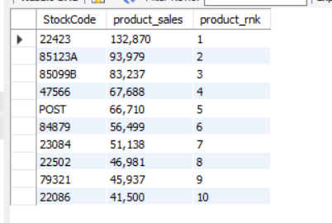

-----> Query 3 <------

select distinct StockCode , round(sum(quantity ) over(partition by StockCode)) as Quantity_sold

from table_retail

where quantity > 0

order by Quantity_sold desc

limit 5;

this simple query is to identify the products that have sold the most quantity in the given period.

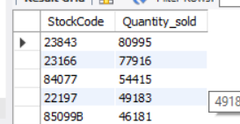

-----> Query 4<------

with cte as (select month,total_sales, lead(total_sales) over(order by month desc) as last_month_sales from

(select distinct Extract(month from invoicedate) as month,

round(sum((price * quantity)) over(partition by Extract(month from invoicedate))) total_sales

from table_retail

where quantity > 0 and Extract(year from invoicedate) = '2011' ) y

order by month desc)

select *,concat(round(((total_sales - last_month_sales)/last_month_sales) *100 ,2), '%') "sales_change_over_months"

from cte;

This SQL query calculates the monthly sales change percentage for the year 2011 in the online retail business, By calculating the percentage change in sales from one month to the next, the query can help identify whether sales are increasing or decreasing over time. This information can be useful for forecasting future sales and making business decisions such as adjusting inventory levels, marketing efforts, and production plans.

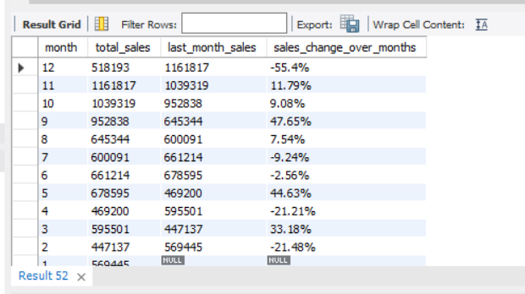

-----> Query 5<------

WITH customer_sales AS (

SELECT

customer_id,

country,

ROUND(SUM(quantity * price), 2) AS total_sales

FROM table_retail

GROUP BY customer_id, country

),

ranked_sales AS (

SELECT

customer_id,

country,

total_sales,

ROW_NUMBER() OVER(PARTITION BY country ORDER BY total_sales DESC) AS sales_rank

FROM customer_sales

)

SELECT

country,

customer_id,

total_sales, sales_rank

FROM ranked_sales

WHERE sales_rank <= 3

ORDER BY country, total_sales DESC;

This query selects the top 3 customers for each country based on their sales rank and returns their country, customer ID, and total sales.

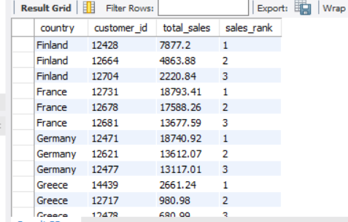

-----> Query 6<------

SELECT customer_id, total_sales

FROM (

SELECT customer_id, ROUND(SUM(quantity * price)) AS total_sales,

NTILE(5) OVER (ORDER BY ROUND(SUM(quantity * price)) DESC) AS percentile

FROM table_retail

group by customer_id

) AS x

WHERE percentile = 1;

This query divides the customers into five groups based on their total sales, with group 1 containing the customers with the highest total sales. The outer query then selects only the customers in group 1, which represents the top 20% of customers according to total sales.

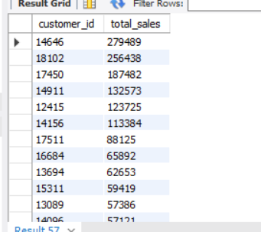

-----> Query 7<------

select distinct country , year, count(*) over(partition by year, country) number_of_orders

from (select distinct invoice , Extract(year from cast(invoicedate as date)) as year , country

from table_retail) X

order by 1 , 2;

This query will give us the count of total orders for each country for each year

